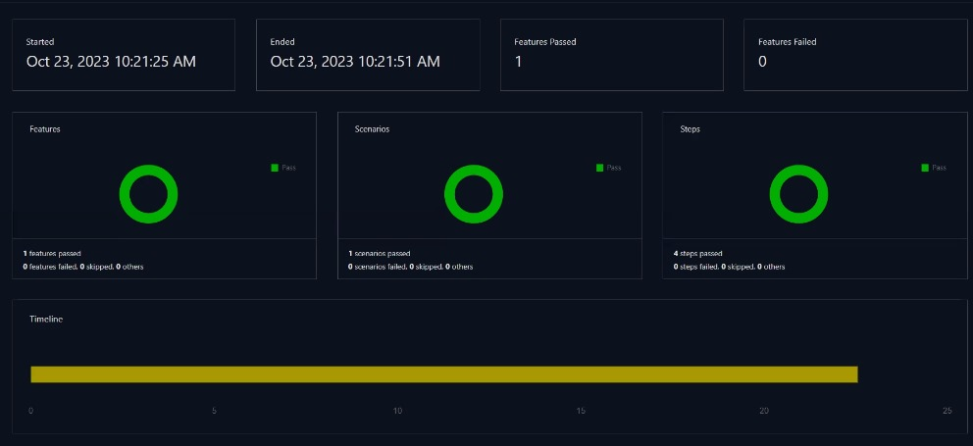Integration of Jenkins with Extent Reports by using HTML plugin

**Output:**